Aerodynamics

June 2024

Inverted airfoil analysis

Meshing

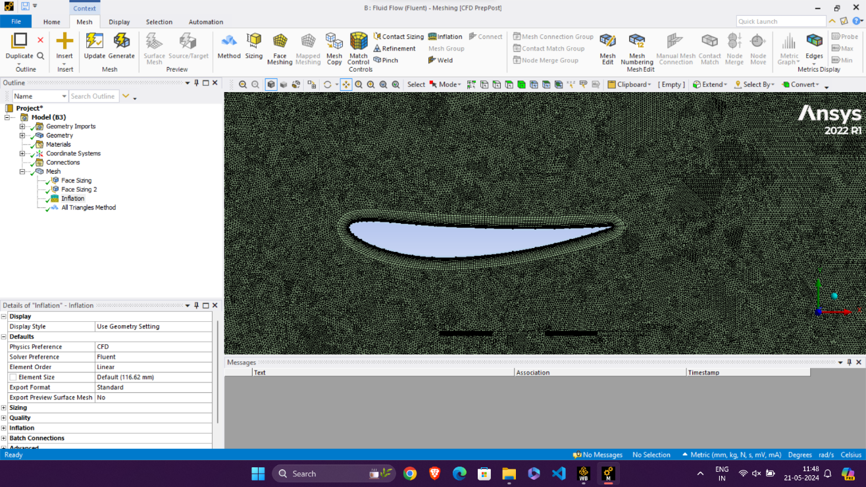

* Face Meshing – 1.6 mm for outer CV
* Face Meshing – 0.8 mm for inner CV
* Inflation – First layer thickness 0.08 mm with growth rate 1.2, 12 layers
* Orthogonal Quality – 0.15 to 1
* All triangles method
* Manual mesh connection

CFD Results

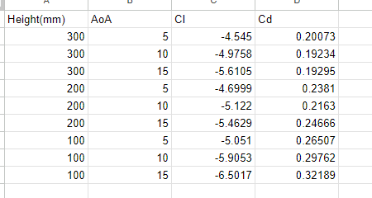

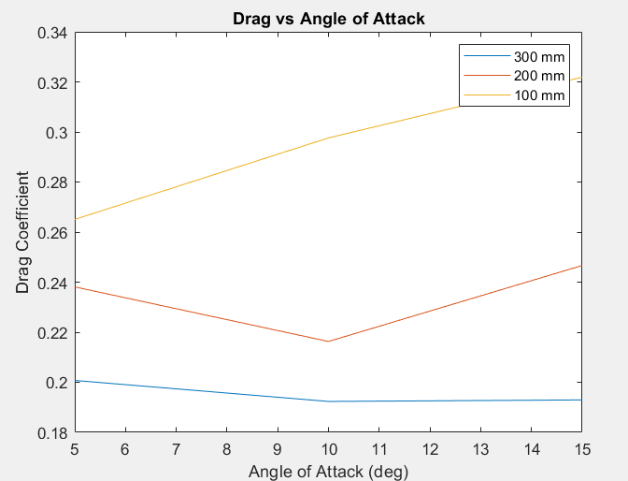

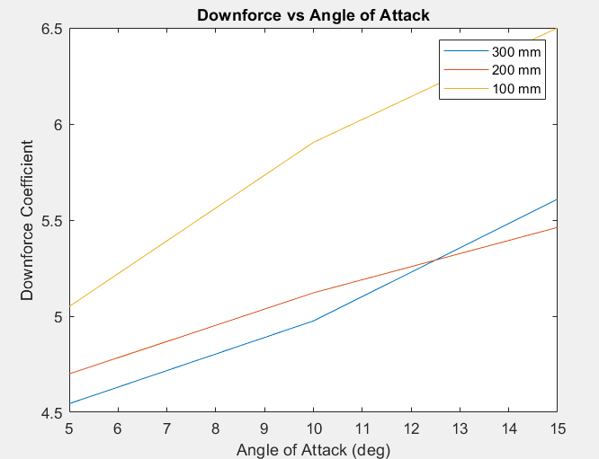

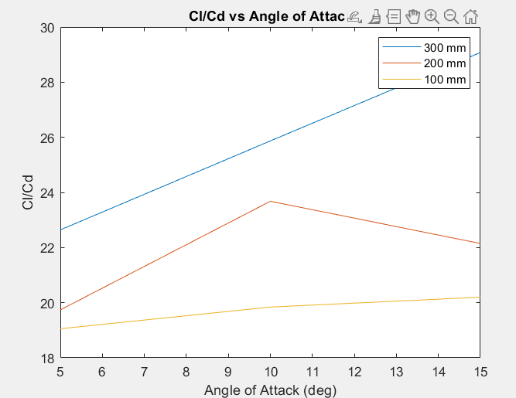

Multi Element Analysis –

Meshing –

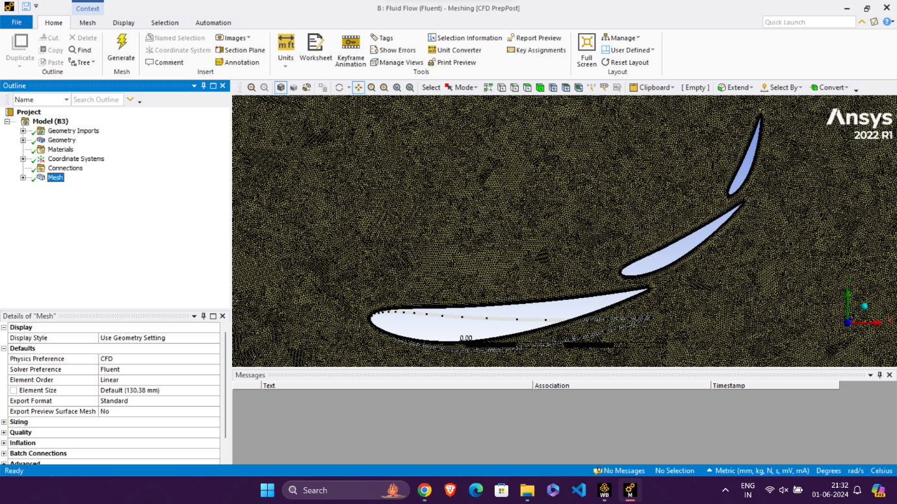

* Face Meshing – 1.4 mm for outer CV
* Face Meshing – 0.6 mm for inner CV
* Inflation – First layer thickness 0.06 mm with growth rate 1.2, 12 layers
* Orthogonal Quality – 0.09 to 1
* All triangles method
* Manual mesh connection

Geometry-

1st element -

c = 100 mm

AoA = 6 deg

LE = (0, 0)

2nd element-

c = 50 mm

AoA = 30 deg

LE = (85.5, 16)

3rd element-

c = 30 mm

AoA = 68 deg

LE = (128, 44)